High-level-Document

Food Delivery App

Table of Contents

1. Introduction

1.1 Purpose

1.2 Scope

2. Objectives

2.1 Stakeholders

3. Assumptions and Prerequisites

4. Technology Stack

5. Architectural Overview

5.1 System Architecture

6. Features

6.1 User Authentication

6.2 Restaurant Management

6.3 Order Processing System

6.4 Payment Management

6.5 User Profile Management

7. Non-Functional Requirements

8. Risks and Mitigation Strategies

9. Future Enhancements

10. Conclusion

**1. Introduction**

   The purpose of a food delivery app is to provide a convenient and efficient way for users to order food from restaurants and facilitate the seamless ordering and delivery of food to their desired location.

**1.1. Purpose**

This high-level design document provides an overview of the architecture and design principles for the development of a Food Delivery application. It focuses on its main components, data flows, user interfaces and external integrations. This provides a conceptual overview of how the system works. It serves as a guide for developers, architects and stakeholders involved in understanding and implementing the architecture.

**1.2. Scope**  
 The scope of a food delivery app includes creating a seamless platform for users to browse restaurants, place orders, track deliveries, and provide feedback. It also involves enabling restaurants to manage their profiles, menus, and orders efficiently, while ensuring secure payment processing, excellent customer support, and continuous improvement of the app's features and services.

**2. Objectives**

* Providing convenience: Offering users a convenient way to order food from a variety of restaurants without the need to physically visit them.
* Expanding restaurant reach: Allowing restaurants to reach a broader customer base by offering delivery services through the app.
* Enhancing user experience: Providing a user-friendly interface for browsing menus, placing orders, and tracking deliveries in real-time.
* Ensuring efficiency: Streamlining the ordering process and optimizing delivery routes to ensure timely and efficient delivery of food.
* Promoting customer satisfaction: Focusing on delivering high-quality service, accurate orders, and timely deliveries to enhance customer satisfaction and encourage repeat business.
* Supporting business growth: Facilitating the growth of partner restaurants by increasing their visibility and sales through the app platform.

**2.1 Stakeholders**

1. **Users**: The primary stakeholders who use the app to order food and track deliveries.
2. **Restaurants**: Partner establishments that list their menus and fulfill orders through the app.
3. **Delivery Personnel**: Drivers or couriers responsible for picking up orders from restaurants and delivering them to users.
4. **App Developers**: The team responsible for designing, developing, and maintaining the app.
5. **Customer Support Team**: Representatives who assist users and restaurants with inquiries, issues, and feedback.
6. **Payment Gateway Providers**: Companies that facilitate secure payment processing within the app.

**3. Assumptions and Prerequisites**

**Assumptions:**

1. Connectivity: Reliable internet connection is accessible for users.
2. Demand: There exists ample demand for food delivery services in the targeted market.
3. Restaurant Participation: Restaurants are inclined to collaborate with the app for service provision.
4. Payment Preferences: Users are amenable to digital payment methods.

**Prerequisites:**

1. App Interface: Development of an intuitive and user-friendly mobile application interface.
2. Restaurant Partnerships: Establishment of partnerships with restaurants for inclusion on the platform.
3. Delivery Personnel: Recruitment and training of delivery personnel to fulfill orders efficiently.
4. Payment Integration: Integration with a secure payment gateway to facilitate seamless transactions.
5. Regulatory Compliance: Adherence to food safety standards and regulations governing food delivery services.

**4. Technology Stack**

**4.1. Frontend Development:**

* + Framework: Angular or React for building responsive, interactive user interfaces.
  + Languages: HTML, CSS, JavaScript/TypeScript.
  + UI Libraries: Bootstrap or Material UI for styling and layout.
  + HTTP Client: Angular Http Client for making HTTP requests to backend services.

**4.2. Backend Development:**

* + Framework: Spring Boot for building RESTful APIs and microservices.
  + Language: Java for backend logic implementation.
  + Database: MySQL for storing user data, server details, performance, etc.
  + ORM: Spring Data JPA or Hibernate for object-relational mapping.
  + Authentication: Spring Security for handling user authentication and authorization.

**5. Architectural Overview:**

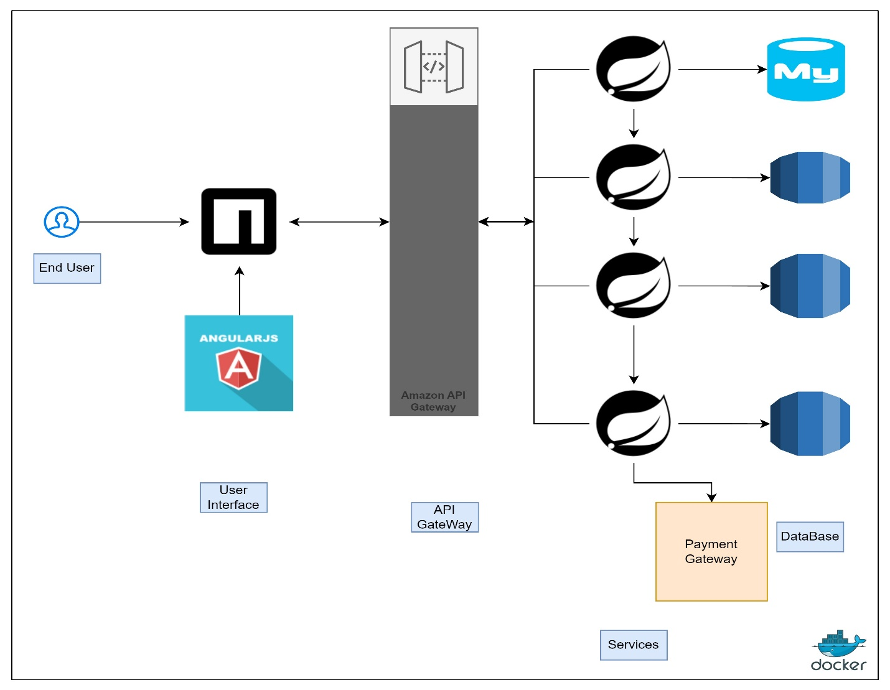

  Fig: Architecture

**5.1. System Architecture**

The system architecture for a food delivery app encompasses several interconnected components, each fulfilling specific functionalities to ensure a seamless user experience and efficient operations. Here's a formal breakdown of the architecture:

**5.1.1. Client Application Layer**:

* **Mobile Application**: A native or hybrid mobile application serves as the primary interface for users to interact with the platform. It allows users to browse restaurants, view menus, place orders, and track deliveries.
* **Web Application (optional)**: An alternative web-based interface accessible via web browsers provides users with similar functionalities as the mobile app, catering to those who prefer desktop or laptop usage.

**5.1.2. Backend Services Layer**:

* **User Management Service**: Handles user authentication, registration, and profile management, ensuring secure access to the platform.
* **Restaurant Management Service**: Manages restaurant-related data, including information, menus, availability, and order processing functionalities.
* **Order Management Service**: Orchestrates the processing of orders, calculates pricing, manages payments, and updates order statuses in real-time.
* **Payment Management Service**: Encompass various aspects of handling payments, including processing transactions, managing billing and invoicing and ensuring compliance with relevant financial regulations.

**5.1.3. Database Layer:**

* **User Database**: Stores user profiles, authentication credentials, preferences, and order histories.
* **Restaurant Database**: Maintains information about restaurants, menus, operating hours, and availability.
* **Order Database**: Stores detailed information about orders, including items ordered, transaction records, delivery details, and order statuses.

**5.1.4. External Integrations**:

* **Payment Gateway Integration**: Interfaces with external payment gateway services to securely process transactions, handle payment authorizations, and manage refunds.
* **Mapping and Geolocation Services Integration**: Utilizes APIs provided by mapping and geolocation service providers to facilitate address validation, geocoding, and route optimization for order deliveries.

**6. Features**

**6.1 User Authentication**

* **Client Application**: The frontend application where users interact with the login and registration screens.
* **Backend Server**: The server-side application responsible for handling user authentication and registration requests.
* **Database:** Stores user credentials and other related information securely.

**6.1.1. User Registration:**

* When a user wants to register, they provide their details such as email, username, password, etc. on the client application.
* The client application sends a registration request to the backend server.
* The backend server receives the request, validates the provided information, and generates a unique user ID.
* It then hashes the password for security and stores the user details (including the hashed password) in the database.

**6.1.2. User Login:**

* When a user wants to log in, they provide their credentials (email/username and password) on the client application.
* The client application sends a login request to the backend server.
* The backend server receives the request and checks if the provided email/username exists in the database.
* If the user exists, it retrieves the stored hashed password from the database and compares it with the hashed password provided by the user during login.
* If the passwords match, the server generates a JWT (JSON Web Token) containing the user's ID and other relevant information.
* The server sends the JWT as a response to the client application, indicating successful login.
* The client application stores the JWT securely (e.g., in local storage or session storage) for subsequent authenticated requests.

**6.2 Restaurant Management**

**1. Create/Update/Delete Restaurant Profile**:

Allow restaurant owners to create new profiles for their establishments with details such as name, address, cuisine type, contact information, opening hours, and menu items. Support operations for updating or deleting existing restaurant profiles as needed.

**2. Manage Menu Items**:

Provide functionalities for adding, editing, and removing menu items from restaurant profiles. Enable restaurant owners to specify details like item name, description, price, dietary information, and availability.

**3. Handle Reviews and Ratings**:

Allow users to submit reviews and ratings for restaurants based on their dining experiences. Implement mechanisms for displaying average ratings and reviews on restaurant profiles.

**4. Ordering and Delivery**:

Integrate online ordering and delivery functionalities to enable users to place food orders directly from restaurant profiles. Collaborate with delivery partners or establish an in-house delivery system for fulfilling orders.

**5. Promotions and Events**:

Allow restaurants to showcase special promotions, discounts, and events on their profiles to attract customers. Implement features for scheduling and managing promotional campaigns and events.

**6.3 Order Processing System**

**1. Order Placement:** Users browse through available restaurants and menus on the app, select items they wish to order, and add them to their cart. They then proceed to checkout, where they provide delivery details and make payment.

**2. Order Confirmation**: Upon successful payment, the app confirms the order, providing users with an order confirmation screen or email. The order details are sent to the restaurant for preparation.

**6.4 Payment Management**

**1. Adding Payment Methods:** Allow users to securely add and manage payment methods such as credit/debit cards, digital wallets, and bank accounts to their Zomato accounts.

**2. Making Payments:** Enable users to make payments for food orders, restaurant reservations, delivery fees, etc., using their preferred payment methods. Implement secure checkout flows with real-time validation and error handling to ensure smooth payment processing.

**3. Transaction History:** Provide users with access to their transaction history, including details such as transaction date, amount, payment method used, and transaction status (e.g., pending, completed, failed).

**6.5 User Profile Management**

• Display the user's profile picture, show user details such as name, email.

• Display the primary delivery address.

• Options to edit personal information, change passwords.

• Manage payments methods, allowing users to add or remove cards.

**7. Non-Functional Requirements**

**1. Performance**

The system should ensure fast loading times, respond promptly to user interactions and able to handle a large of concurrent users and transactions without significant performance degradation.

**2. Scalability**

The system should be able to handle a large number of concurrent users and fluctuating traffic loads. Utilize scalable cloud infrastructure and horizontal scaling techniques.

**3. Reliability**

The system should be reliable, with minimal errors, crashes, or data inconsistencies. Automated monitoring and alerting systems should be in place to detect and respond to issues proactively, minimizing the impact on users.

**4. Security**

Implement robust security measures to protect user data, payment information, and transaction integrity. This includes encryption, secure authentication, and adherence to industry security standards.

**5. Backup and Recovery**

Implement regular data backups and disaster recovery procedures to ensure data integrity and availability in the event of system failures or disasters.

**8. Risks and Mitigation Strategies**

**1.Technical issue**

Risk: Potential system failures or bugs.

Mitigation: Rigorous testing, ongoing monitoring, and dedicated maintenance team.

**2. Security Breaches**

Risk: Data breaches or cyberattacks.

Mitigation: Robust security measures, regular audits, and employee training.

**3. Delivery Issues**

Risk: Delays or errors in deliveries.

Mitigation: Effective tracking systems, clear communication channels, and strong partnerships with delivery providers.

**4. Financial Instability**

Risk: Fluctuating demand or high operating costs.

Mitigation: Comprehensive financial planning, monitoring, and adjustments to pricing or cost structures.

**5. Brand Reputation**

Risk: Negative reviews or public relations crises.

Mitigation: Prioritizing customer satisfaction, transparency, and proactive brand management.

**9. Future Enhancements**

1. **Advanced Personalization:** Implement AI-driven recommendation engines to offer personalized menu suggestions based on user preferences, order history, and dietary restrictions.
2. **Voice Ordering**: Introduce voice-activated ordering capabilities to enable users to place orders hands-free using voice commands through virtual assistants like Alexa or Google Assistant.
3. **Subscription Services:** Offer subscription-based meal plans or loyalty programs for frequent users, providing discounts, exclusive offers, and perks to incentivize repeat orders.
4. **Social Integration:** Enable social media sharing and integration within the app, allowing users to share their favorite dishes, reviews, and dining experiences with friends and followers.

**10. Conclusion**

The food delivery app presents a promising solution for modern consumers seeking convenient access to a diverse range of culinary delights from the comfort of their homes. With its user-friendly interface, extensive restaurant selection, and efficient order processing system, the app offers unparalleled convenience and flexibility for users to explore and indulge in their favorite dishes with ease. Through seamless integration of technology, robust security measures, and a commitment to customer satisfaction, the app has the potential to revolutionize the way people experience dining, catering to their evolving preferences and lifestyle needs. By continuously innovating and adapting to market trends, the app is poised for sustained growth and success in the competitive food delivery industry.

Ultimately, the food delivery app not only connects users with delicious meals but also fosters a sense of community and culinary exploration, enriching the dining experience for all involved parties. As it continues to evolve and expand its offerings, the app remains dedicated to delivering excellence in service, convenience, and culinary delight to its valued users.